Students Fest Directory

Participants List

**http://localhost:8080/StudentFest_Registration/student/list**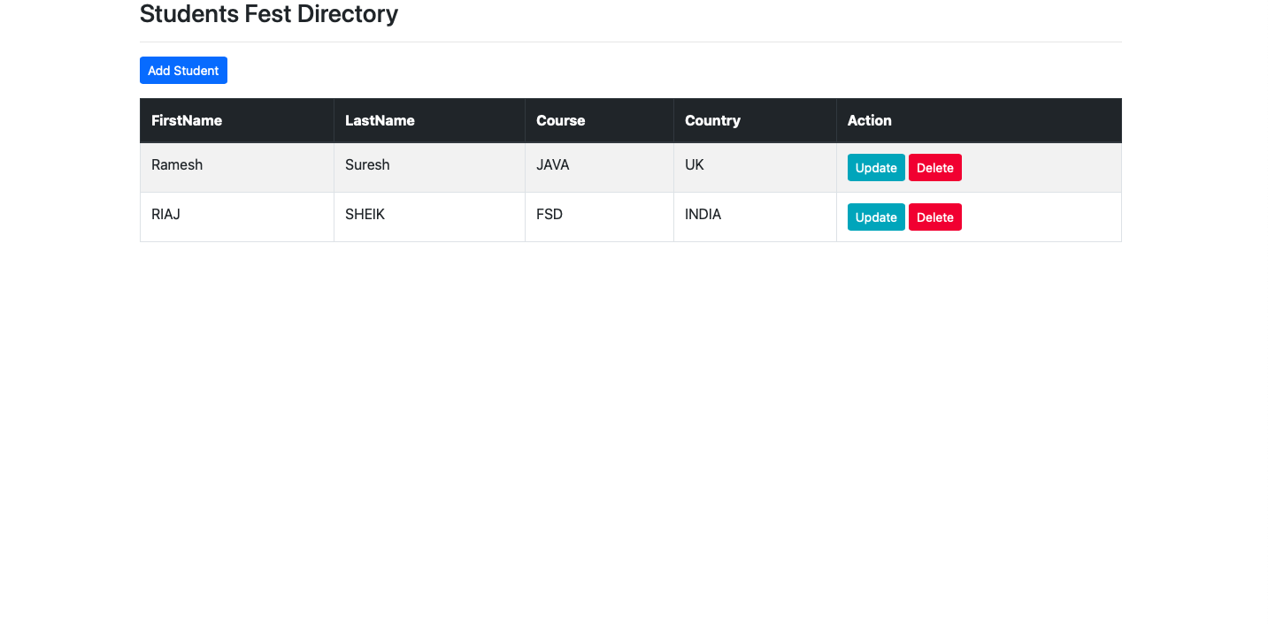

Participants details update

URL - <http://localhost:8080/StudentFest_Registration/student/showFormForUpdate?studentId=1>

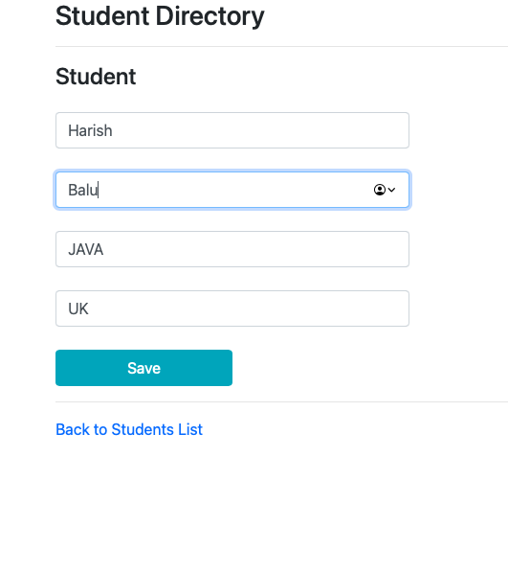

Updated Details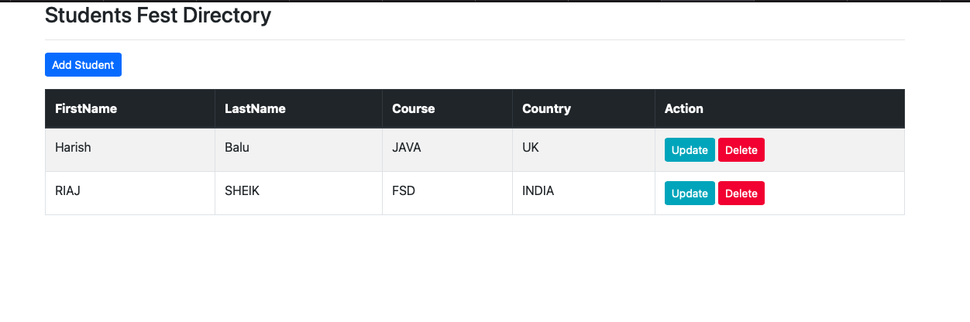

Delete Participant

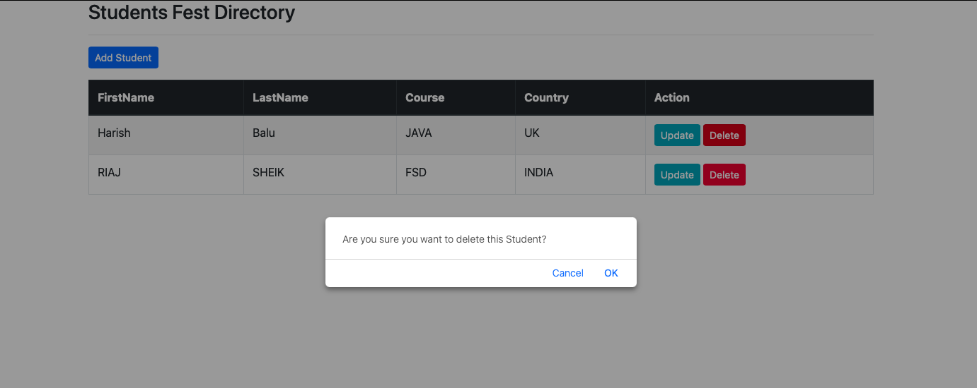

After delete Harish

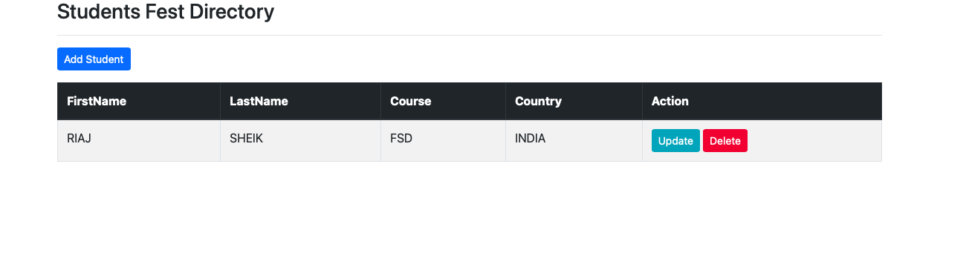

Add Participants

<http://localhost:8080/StudentFest_Registration/student/showFormForAdd>

Student Data entry-form

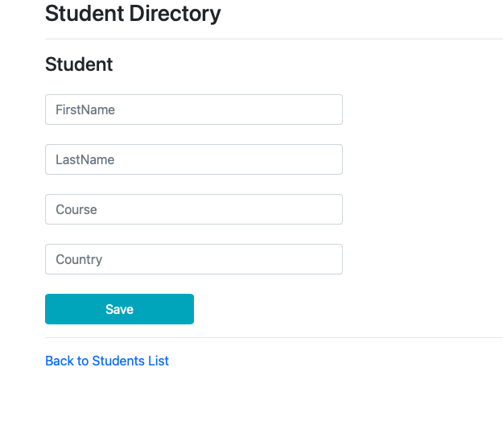

Required Fields filling

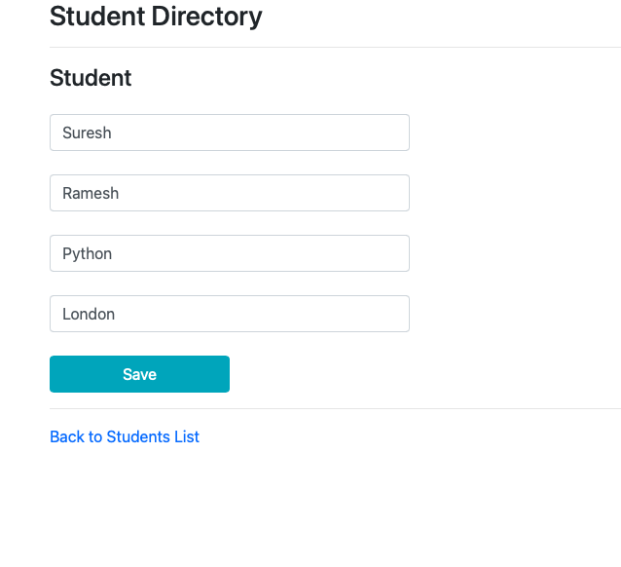

Student details after adding a participant

